**Rockbuster Data Directory**

**Table of Contents**

1. Entity Relationship Diagram…………...…………………………………………………………………………2
2. Fact Tables………………..……….……………………………………………………………………………….3

2.1 Payment………………………………………………………………………………………………………..3

2.2 Rental…………………………………………………………………………………………………………..3

1. Dimension Tables………………………………………………………………………………………………….5

3.1 Film……………………………………………………………………………………………………………..5

3.2 Staff……………………………………………………………………………………………………………..6

3.3 Customer……………………………………………………………………………………………………….7

3.4 Address………………………………………………………………………………………………………..8

3.5 Inventory……………………………………………………………………………………………………….9

3.6 Actor……………………………………………………………………………………………………………9

3.7 City…………………………………………………………………………………………………………….10

3.8 Store…………………………………………………………………………………………………………..10

3.9 Category………………………………………………………………………………………………………11

3.10 Country………………………………………………………………………………………………………11

3.11 Film_Actor……………………………………………………………………………………..……………12

3.12 Film_Category………………………………………………………………………………………..…….12

3.13 Language……………………………………………………………………………………………………13

1. **Entity Relationship Diagram**

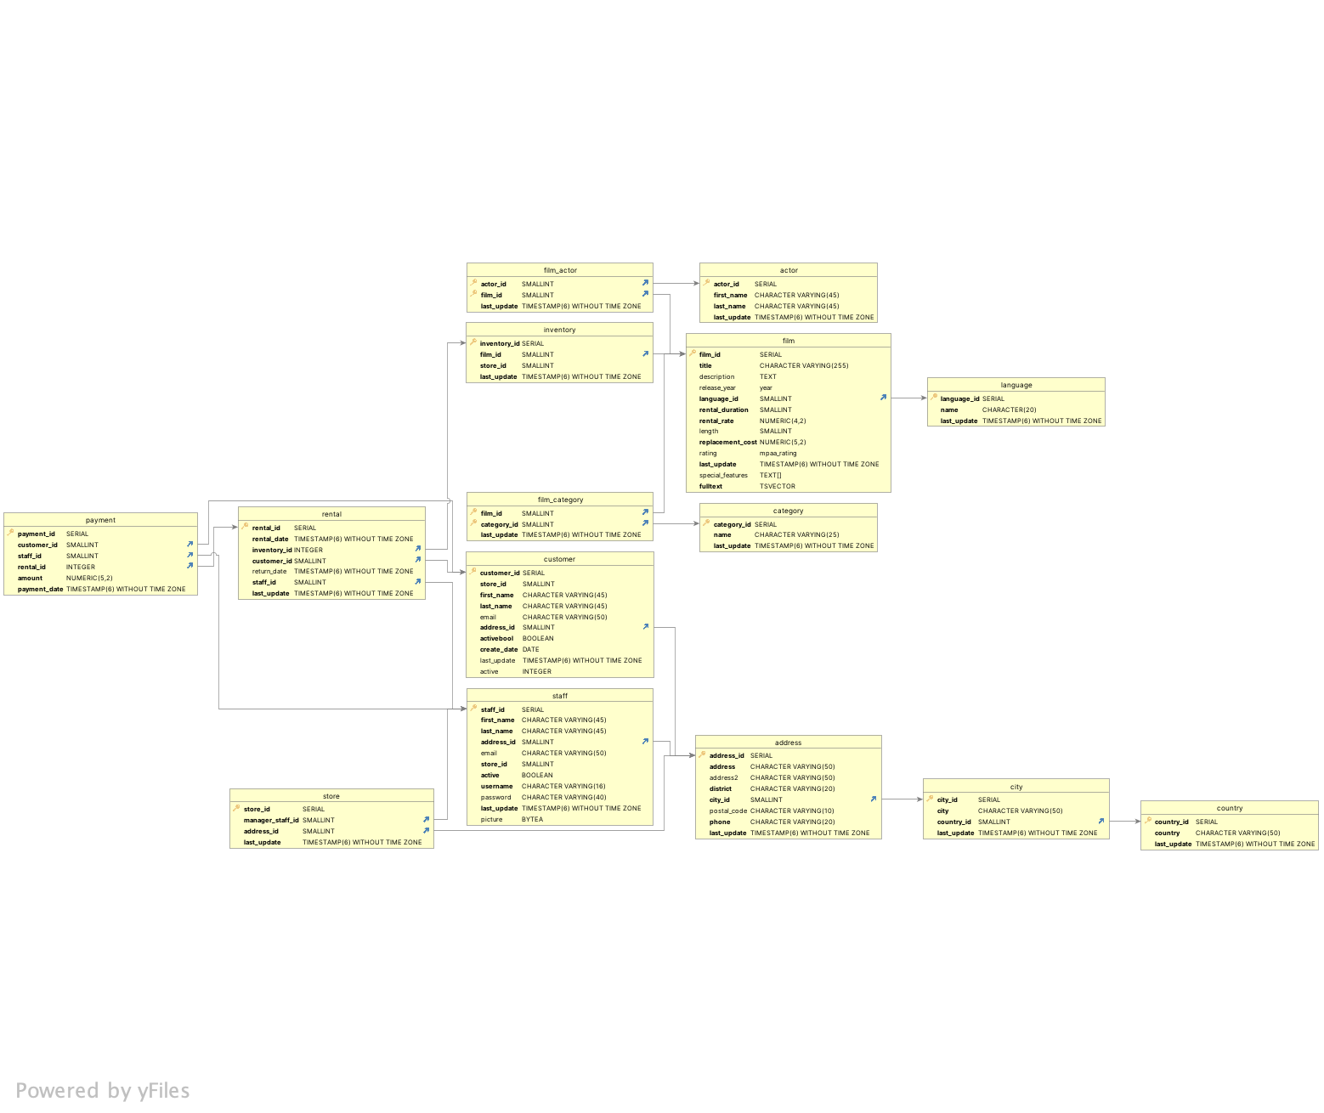

1. **Fact Tables**

| **Name of Table** | **Column** | **Data Type** | **Description** |
| --- | --- | --- | --- |
| Payment | payment_id | Serial | Payment identifier |
| customer_id | Small int | Customer identifier |
| staff_id | Small int | Staff identifier |
| rental_id | integer | Rental ID |
| Amount | Numeric (5,2) | Amount of payment due |
| Payment_date | Timestamp (6) without timezone | Date of payment |
| **Links to** | **Join** | | **Description** |
| Customer | Payment.customer_id = customer.customer_id | | Foreign key constraint referencing customer.customer_id |
| Staff | Payment.staff_id = staff.staff_id | | Foreign key constraint referencing staff.staff_id |
| Rental | Payment.rental_id = rental.rental_id | | Foreign key constraint referencing rental_rental_id |
| **Links From:** None | | | |
| Unique Keys: payment_id | | | |

| **Name of Table** | **Column** | **Data Type** | **Description** |
| --- | --- | --- | --- |
| Rental | Rental_id | serial | Rental identifier |
| Rental_date | Timestamp (6) without timezone | Date of rental |
| Inventory_id | integer | Inventory identifier |
| Customer_id | Small int | Customer identifier |
| Return_date | Timestamp (6) without timezone | Return date |
| Staff_id | Small int | Staff identifier |
| Last_update | Timestamp w/o Time Zone | Time of last update |
| **Links to** | **Join** | | **Description** |
| Customer | rental.customer_id = customer.customer_id | | Foreign key constraint referencing customer.customer_id |
| Staff | rental.staff_id = staff.staff_id | | Foreign key constraint referencing staff.staff_id |
| Inventory | rental.intventory_id = inventory.inventory_id | | Foreign key constraint referencing inventory.inventory_id |
| **Links from** | **Join** | | **Description** |
| Payment | Payment.rental_id = rental.rental_id | | Foreign key constraint referencing rental.rental_id |

1. **Dimension Tables**

| **Name of Table** | **Column** | **Data Type** | **Description** |
| --- | --- | --- | --- |
| Film | Film_id | Serial | Film identifier |
| Title | Character varying (255) | Film title |
| Description | Text | Film description |
| Release_year | Year | Film release year |
| Language_id | Small Int | Language of the film |
| Rental_duration | Small Int | Rental duration |
| Rental_rate | Numeric (4,2) | Rental rate |
| Length | Small Int | Film length |
| Replacement_cost | Numeric(5,2) | Replacement cost of film |
| Rating | Mpaa_rating | Film rating |
| Last_update | Timestamp (6) without timezone | Last update time |
| **Links to** | **Join** | | **Description** |
| Language | Film.language_id = language.language_id | | Foreign key constraint referencing language.language_id |
| **Links from** | **Join** | | **Description** |
| film_category | Film_category.film_id = film.film_id | | Foreign key constraint referencing film.film_id |
| film_actor | Film_actor.film_id = film.film_id | | Foreign key constraint referencing film.film_id |
| inventory | Inventory.film_id = film.film_id | | Foreign key constraint referencing film.film_id |
| Unique Keys: film_id, title, description | | | |

| **Name of Table** | **Column** | **Data Type** | **Description** |
| --- | --- | --- | --- |
| Staff | Staff_id | Serial | Staff identifier |
| First_name | Character varying (45) | Staff member first name |
| Last_name | Character varying (45) | Staff member last name |
| Address_id | Small int | Address identifier |
| Email | Character varying (50) | Staff member email address |
| Store_id | Small int | Store identifier |
| Active | Boolean | Determines if the staff member is active |
| Username | Character varying (16) | Username of staff member |
| Password | Character Varying (40) | Password of staff member |
| Last_update | Timestamp (6) without timezone | Last update time |
| Picture | Bytea | Staff member picture |
| **Links to** | **Join** | | **Description** |
| address | Staff.address_id = address.address_id | | Foreign key constraint referencing address.address_id |
| **Links from** | **Join** | | **Description** |
| store | Store.manager_staff_id = staff.staff_id | | Foreign key constraint referencing staff.staff_id |
| rental | Rental.staff_id = staff.staff_id | | Foreign key constraint referencing staff.staff_id |
| payment | Payment.staff_id = staff.staff_id | | Foreign key constraint referencing staff.staff_id |
| Unique keys: staff_id, username, picture | | | |

| **Name of Table** | **Column** | **Data Type** | **Description** |
| --- | --- | --- | --- |
| Customer | Customer_id | Serial | Customer identifier |
| Store_id | Small int | Store identifier |
| First_name | Character varying (45) | Customer first name |
| Last_name | Character varying (45) | Customer last name |
| Email | Character varying (50) | Customer email address |
| Address_id | Small int | Address identifier |
| Activebool | Boolean | Determines if the customer is active |
| Create_date | Date | Date the customer profile was created. |
| Last_update | Timestamp without timezone | Last update time |
| Active | Integer | Active status |
| **Links to** | **Join** | | **Description** |
| address | customer.address_id = address.adress_id | | Foreign key constraint referencing address.address_id |
| **Links from** | **Join** | | **Description** |
| payment | Payment.customer_id = customer.customer_id | | Foreign key constraint referencing customer.customer_id |
| rental | Rental.customer_id = customer.customer_id | | Foreign key constraint referencing customer.customer_id |
| Unique keys: customer_id | | | |

| **Name of Table** | **Column** | **Data Type** | **Description** |
| --- | --- | --- | --- |
| Address | Address_id | Serial | Address identifier |
| Address | Character varying (50) | First line of the address |
| Address2 | Character varying (50) | Second line of the address |
| District | Character varying (20) | District of the address |
| City_id | Small Int | City identifier |
| Postal_code | Character varying (10) | Address postal code |
| Phone | Character varying (20) | Phone number associated with address |
| Last_update | Timestamp (6) without timezone | Last update time |
| **Links to** | **Join** | | **Description** |
| city | address.city_id = city.city_id | | Foreign key constraint referencing city.city_id |
| **Links from** | **Join** | | **Description** |
| staff | Staff.address_id = address.address_id | | Foreign key constraint referencing address.address_id |
| customer | customer.address_id = address.address_id | | Foreign key constraint referencing address.address_id |
| store | Store.address_id = address.address_id | | Foreign key constraint referencing address.address_id |
| Unique keys: address_id | | | |

| **Name of Table** | **Column** | **Data Type** | **Description** |
| --- | --- | --- | --- |
| Inventory | Inventory_id | Serial | Inventory identifier |
| Film_id | Small int | Film identifier |
| Store_id | Small int | Store identifier |
| Last_update | Timestamp (6) without timezone | Last update time |
| **Link to** | **Join** | | **Description** |
| film | Inventory.film_id = film.film_id | | Foreign key constraint referencing film.film_id |
| **Link from** | **Join** | | **Description** |
| Rental | Rental.inventory_id = inventory.inventory_id | | Foreign key constraint referencing inventory.inventory_id |
| Unique keys: inventory_id | | | |

| **Name of Table** | **Column** | **Data Type** | **Description** |
| --- | --- | --- | --- |
| Actor | Actor_id | Serial | Actor identifier |
| First_name | Character varying (45) | Actor first name |
| Last_name | Character varying (45) | Actor last name |
| Last_update | Timestamp (6) without timezone | Last update time |
| **Link to: None** | | | |
| **Links from** | **Join** | | **Description** |
| film_actor | Film_actor.actor_id = actor.actor_id | | Foreign key constraint referencing actor.actor_id |

| **Name of Table** | **Column** | **Data Type** | **Description** |
| --- | --- | --- | --- |
| City | City_id | Serial | City identifier |
| City | Character varying (50) | Name of city |
| Country_id | Small Int | Country identifier |
| Last_update | Timestamp (6) without timezone | Time of last update |
| **Links to** | **Join** | | **Description** |
| country | City.country_id = country.country_id | | Foreign key constraint referencing country.country_id |
| **Links from** | **Join** | | **Description** |
| address | Address.city_id = city.city_id | | Foreign key constraint referencing city.city_id |
| Unique keys: city_id | | | |

| **Name of Table** | **Column** | **Data Type** | **Description** |
| --- | --- | --- | --- |
| Store | store_id | Serial | Store identifier |
| manager_staff_id | Small int | Manager identifier |
| address_id | Small int | Address identifier |
| last_update | Timestamp (6) without timezone | Last update time |
| **Links to** | **Join** | | **Description** |
| address | Store.address_id = address.address_id | | Foreign key constraint referencing address.address_id |
| staff | Store.manager_staff_id = staff.staff_id | | Foreign key constraint referencing staff.staff_id |
| **Links from: None** | | | |
| Unique keys: store_id | | | |

| **Name of Table** | **Column** | **Data Type** | **Description** |
| --- | --- | --- | --- |
| Category | Category_id | Serial | Category identifier |
| Name | Character varying (25) | Category name |
| Last_update | Timestamp (6) without timezone | Last update time |
| **Links to: None** | | | |
| **Links from:** | **Join** | | **Description** |
| film_category | Film_category.category_id = category.category_id | | Foreign key constraint referencing category.category_id |
| Unique keys: category_id, name | | | |

| **Name of Table** | **Column** | **Data Type** | **Description** |
| --- | --- | --- | --- |
| Country | Country_id | Serial | Country identifier |
| Country | Character varying (50) | Country name |
| Last_update | Timestamp (6) without timezone | Last update time |
| **Links to: None** | | | |
| **Links from** | **Join** | | **Description** |
| city | City.country_id = country.country_id | | Foreign key constraint referencing country.country_id |
| Unique keys: country_id, country | | | |

| **Name of Table** | **Column** | **Data Type** | **Description** |
| --- | --- | --- | --- |
| Film_actor | Actor_id | Small int | Actor identifier |
| Film_id | Small int | Film Identifier |
| Last_update | Timestamp (6) without timezone | Last update time |
| **Links to** | **Join** | | **Description** |
| actor | Film_actor.actor_id = actor.actor_id | | Foreign key constraint referencing actor.actor_id |
| film | Film_actor.film_id = film.film_id | | Foreign key constraint referencing film.film_id |
| **Links from: None** | | | |
| Unique keys: actor_id | | | |

| **Name of Table** | **Column** | **Data Type** | **Description** |
| --- | --- | --- | --- |
| Film_category | Film_id | Small int | Film identifier |
| Category_id | Small int | Category identifier |
| Last_update | Timestamp (6) without timezone | Last update time |
| **Links to** | **Join** | | **Description** |
| film | Film_category.film_id = film.film_id | | Foreign key constraint referencing film.film_id |
| category | Film_category.category_id = category.category_id | | Foreign key constraint referencing category.category_id |
| **Links from: None** | | | |
| Unique keys: film_id | | | |

| **Name of Table** | **Column** | **Data Type** | **Description** |
| --- | --- | --- | --- |
| Language | Language_id | Serial | Language identifier |
| Name | Character varying (20) | Name of the language |
| Last_update | Timestamp (6) without timezone | Last update time |
| **Links to: None** | | | |
| **Links from:** | **Join** | | **Description** |
| film | Film.language_id = language.language_id | | Foreign key constraint referencing language.language_id |
| Unique keys: language_id | | | |